Mini Project Report – Team 21

Interim Report

**Team Members:** Tony Huang, Harsh Thorat, Lojanan Sivanantharuban

**Department:** Computer System Engineering

**University of Auckland**

**20 Symonds Street Auckland 1010**

**Abstract**

This project intends to provide a gaming console experience similar to a Gameboy. Designing a flappy bird game using a FPGA board (Cyclone V 5CEBA4F23C7) with the knowledge learnt from the course COMPSYS305.

**Introduction**

The goal of this project is to design a custom flappy bird themed game using digital logic and VHDL to program a FPGA board.

The rules of the flappy bird game are to keep the bird floating while avoiding obstacles such as pipes and the ground. Since the project is not finished there are more features to come such as extra score, lives and score boosters.

**Game Features**

The flappy bird game is an endless game with one life. Similar to Jetpack Joyride. It currently only has one level and pipes as obstacles. Player will need to “flap” the birds through the opening of the gaps without the bird touching the pipe to score. The background is currently sent in extreme high altitude hence why the bird is not flying straight.

The game currently has the basic logic of flappy bird. A bird that flaps up when clicked, pipes moving from left to right with an opening.

**Setup and game tutorial**

**Equipment needed:** Cyclone V 5CEBA4F23C7, PS2 mouse, Cables, Screen.

Plug everything together, connect the HDMI cable to the back of any monitor. Press the red power on button.

Player can now left click to start the game.

**Design and Implementation**

Our project is incomplete therefore not all the states are implemented, however as we journey through this project we will implement all the states. We have also made use of MIF (memory initialization files) to store data of text, sprites and backgrounds.

Below is the Mealy FSM diagram for the sprite animation that we have implemented into our game:

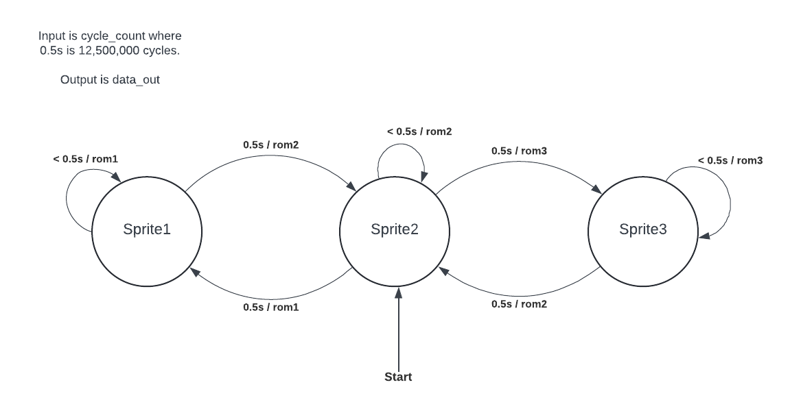

This is the current state of the block diagrams, Screenshotting in Quartus makes it too blurry to be visible.

